
Assignment
Spring 2026 2nd Semester
Course Title: Circuit Analysis Lab
Course Code: CMPE-121L
Topic(s): Lab 11 Verification of Norton’s Theorem
SUBMITTED TO: Mr.Mehmood-ul-Haq
SUBMITTED BY:
Waqas Ali (2025-CE-99)
Submission Date: 19 May, 2026
Department of Computer Engineering
University of Engineering and Technology Lahore

Experiment 1
5
V
330
330
330
k
1
A
+
1.672
mA
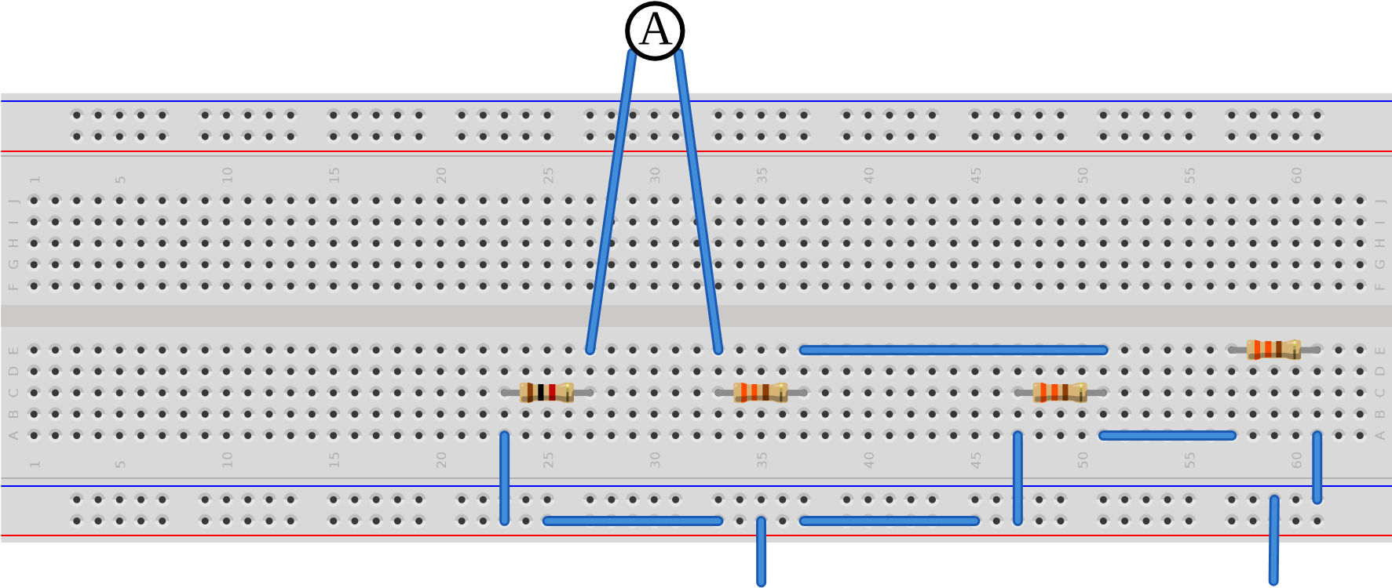
GND 5V(+)
Breadboard circuit layout: Initial assembly with load resistance 𝑅_{𝐿}=1kΩ

Practical Procedure
The objective of this experiment is to verify Norton’s Theorem by simplifying a linear bilateral active two-terminal network into an equivalent circuit consisting of a single constant current source (𝐼_{𝑁}) in parallel with an equivalent resistance (𝑅_{𝑁}). The primary circuit is constructed using three 330Ω resistors and a 1kΩ load resistor (𝑅_{𝐿}), powered by a Regulated Power Supply. For all measurements, the UNI-T UT89XE digital multimeter is utilized to capture the load current, short-circuit current, and looking-back resistance. A supply voltage of 5V is provided from the RPS to the initial circuit to observe the current while the load is connected.
To measure the load current (𝐼_{𝐿}), the multimeter dial is set to the 20mA DC range (indicated by the A— symbol). The black probe is connected to the COM port while the red probe is inserted into the mA 𝜇A terminal. This measurement requires the DMM to be connected in series with the load. To find the Norton current (𝐼_{𝑁}), the load resistor is removed and the terminals are short-circuited through the ammeter to measure the short-circuit current. To determine the Norton resistance (𝑅_{𝑁}), the RPS is removed and short-circuited; the DMM is then set to the 2000Ω range and probes are connected across the load terminals to measure the "looking-back" resistance.
After obtaining 𝐼_{𝑁} and 𝑅_{𝑁}, the Norton equivalent circuit is constructed by setting the current source to the measured 𝐼_{𝑁} value and placing a resistance approximating 𝑅_{𝑁} in parallel with the 1kΩ load resistor. The final objective is to verify whether the equivalent circuit produces the same load current (𝐼_{𝐿}) as recorded in the original network. Theoretical accuracy depends on component linearity; however, minor discrepancies may be observed in simulated or physical environments. Factors such as the internal resistance of the power supply and the burden voltage of the ammeter can introduce slight deviations between the mathematical predictions and the recorded experimental data.
5
V
330
330
330
k
1
A
+
1.672
mA
Falstad: Measurement of Load Current 𝐼_{𝐿} in the original network
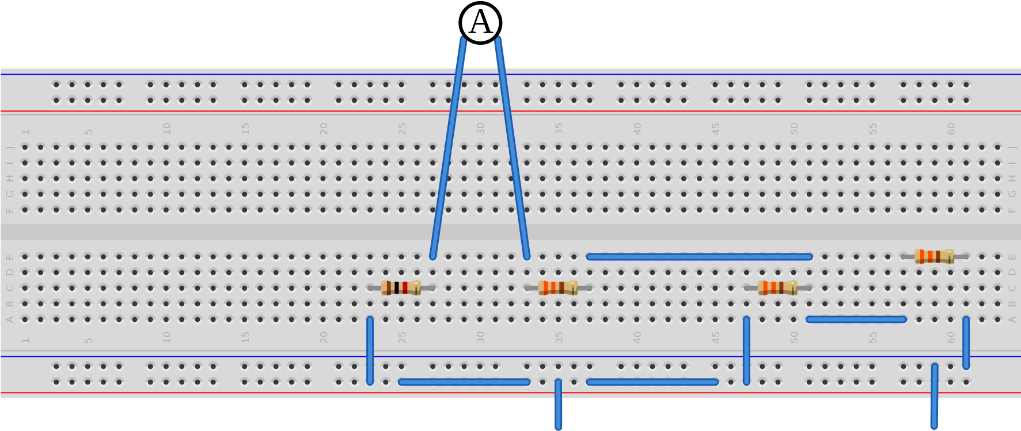
GND 5V(+)
Breadboard: Series ammeter connection for 𝐼_{𝐿} measurement
5
V
330
330
330
A
+
5.051
mA
Falstad: Short-circuit current measurement for 𝐼_{𝑁}
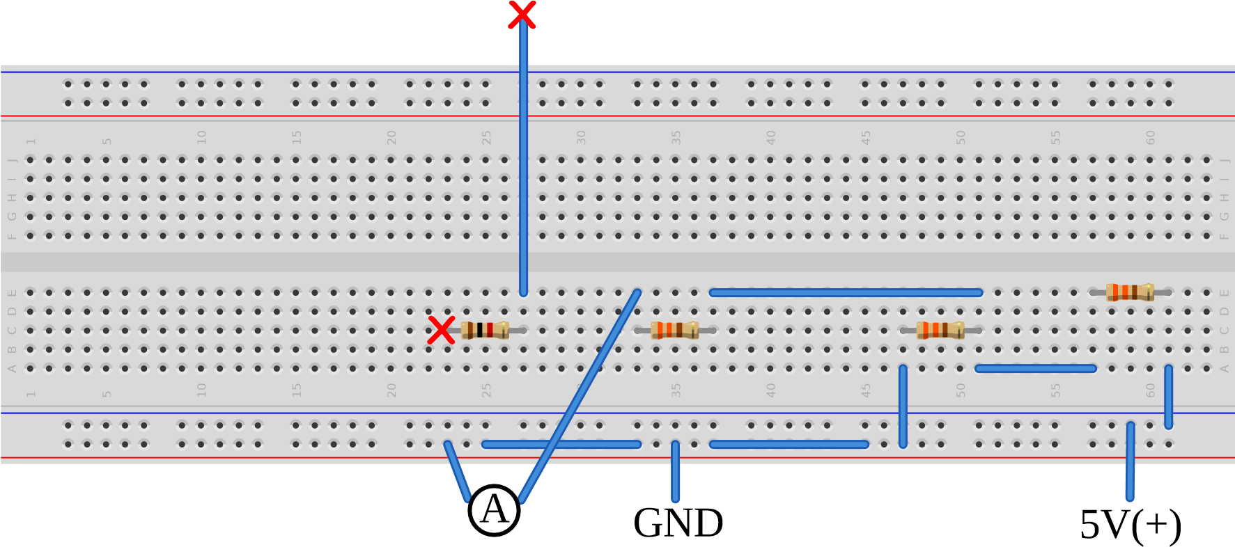
Breadboard: Ammeter shorting the load terminals to measure 𝐼_{𝑁}
330
330
330
Ω
495
Ω
Falstad: Resistance measurement for 𝑅_{𝑁} (Source shorted)
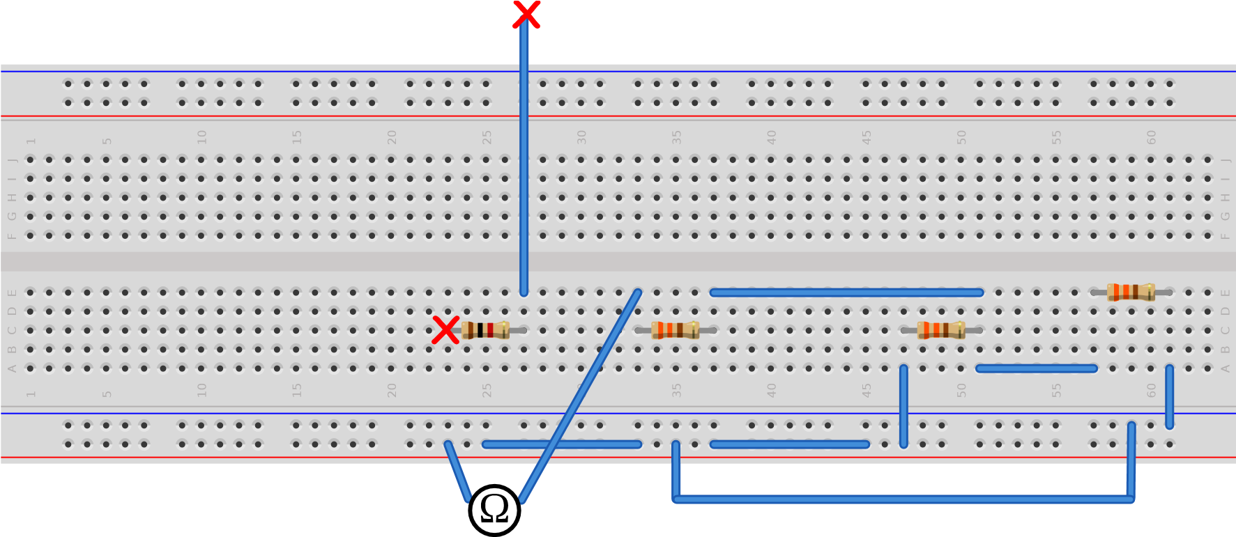
Breadboard: Ohmmeter connection for 𝑅_{𝑁} calculation
495
1
k
A
+
1.672
mA
5.1
mA
Falstad: Verification of 𝐼_{𝐿} using the Norton Equivalent Circuit
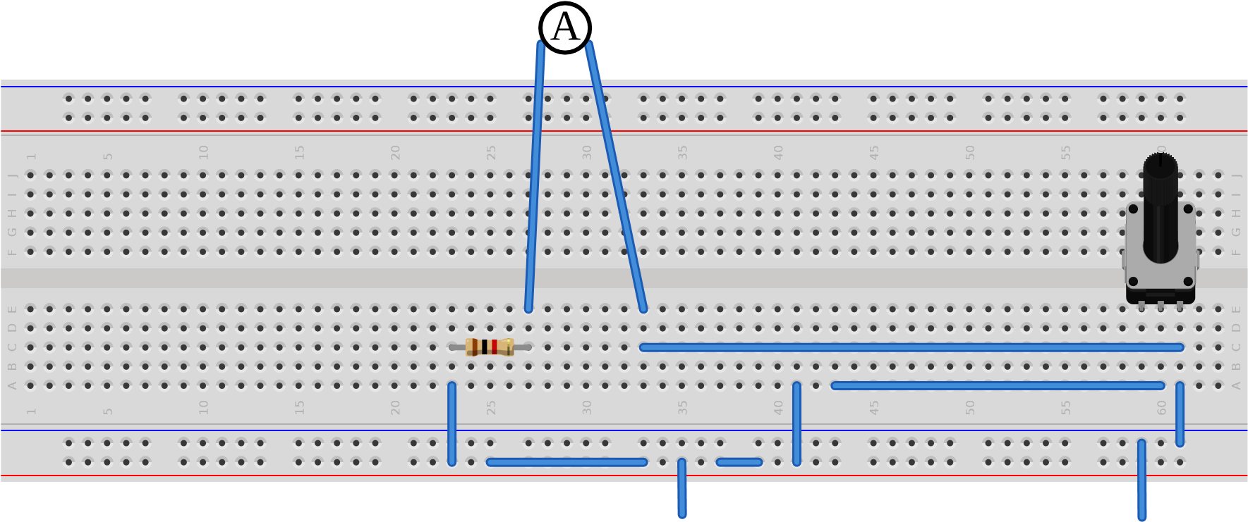
GND 5.051mA(+)
Breadboard: Equivalent circuit using a current source and parallel resistor combination

